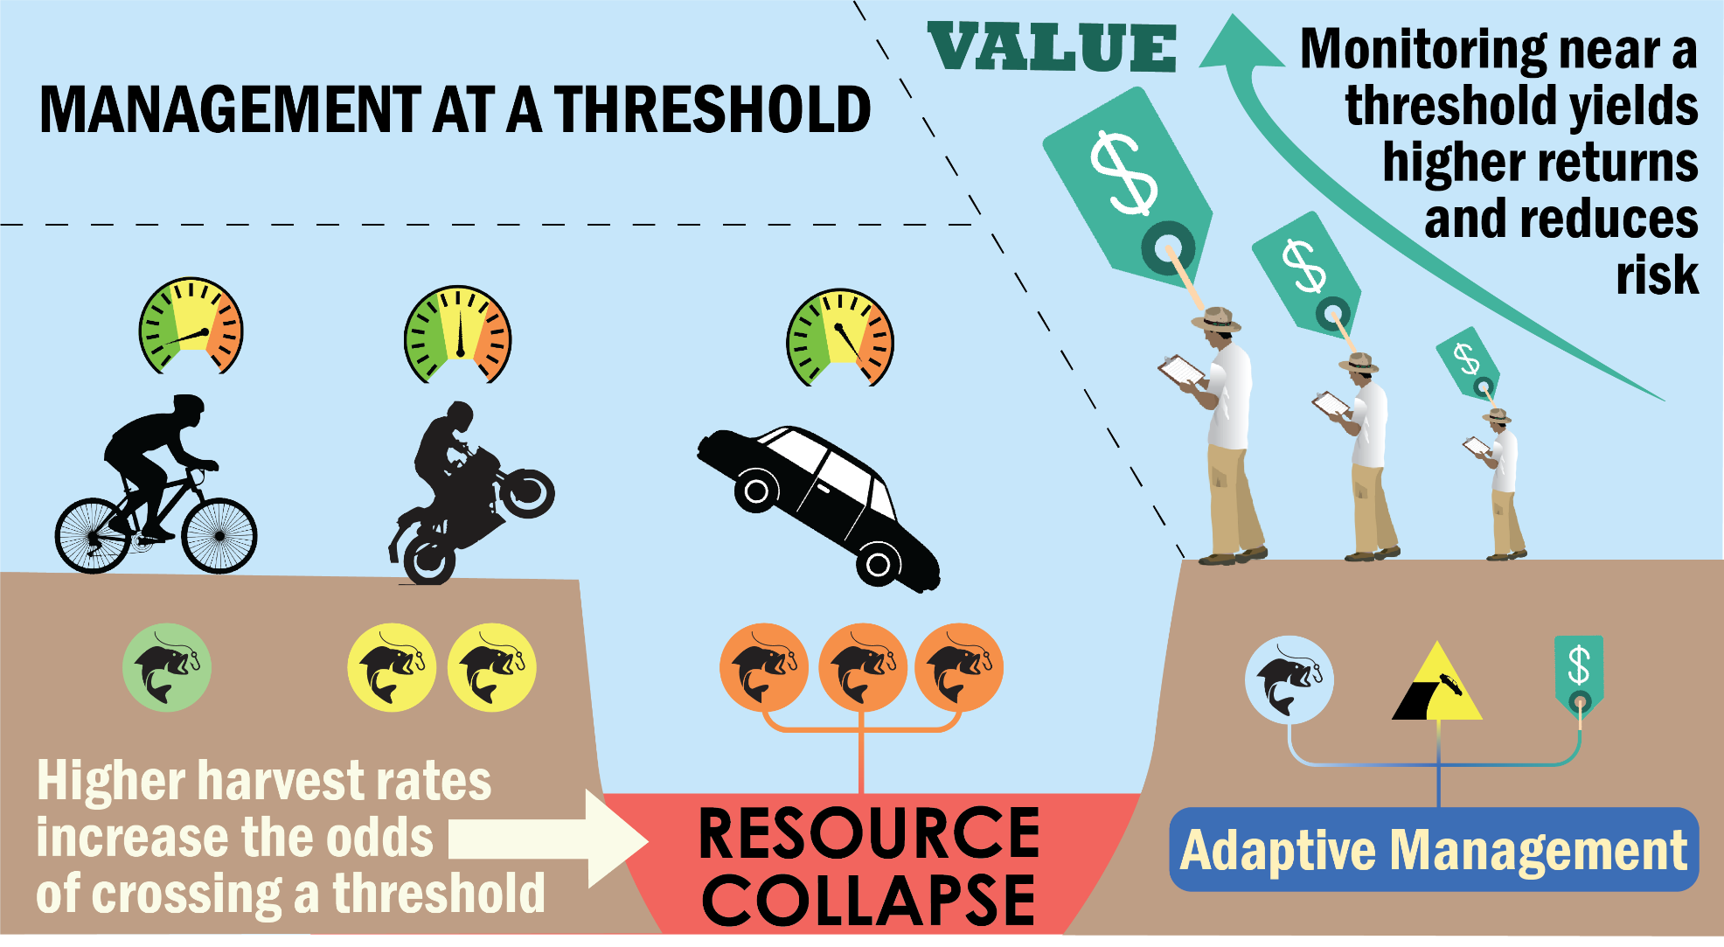
Effective decision-making in a system with an environmental, ecological, or management threshold can be extremely difficult, but is extremely important to avoid detrimental collapses of natural resources. This diagram illustrates how managers must incorporate information about resource harvest intensity, the costs and benefits of monitoring, and distance from a threshold in order to design and implement successful and economically sound management protocols.

